

ROS Interface for P‑Rob

Version 1.0.1

2015-02-24

The information contained in this document is property of F&P Robotics AG and shall not be reproduced in whole or in part without prior written approval of F&P Robotics AG. The information provided herein is subject to changes without notice and should not be constructed as a commitment by F&P Robotics AG. This manual is periodically reviewed and revised. F&P Robotics AG assumes no responsibility for any errors or omissions in this document.

**Copyright © 2011-2015 by F&P Robotics AG. All rights reserved.**

The F&P logo as well as P-Rob®, P-Grip® and myP® are registered trademarks of F&P Robotics AG in Zurich, Switzerland.

**Contents**

1. Concept 3

2. Installing ROS 3

3. Example Program 4

# Concept

A ROS Service can be called from any ROS client, a test example is included in the package. The ROS Server communicates through XMLRPC to the myP API, which includes all necessary functions. To add new ROS services, only the ROS Server has to be extended.

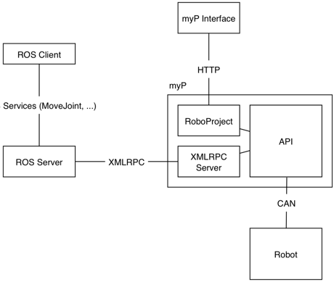

# Installing ROS

1. Install ROS Indigo: <http://wiki.ros.org/ROS/Installation>
2. Create a catkin workspace
3. Copy the F&P package “prob_ros_interface” to the workspace
4. Compile the code and source your setup
   1. $ catkin_make
   2. $ source devel/setup.bash
5. run roscore
6. Now you are ready to run the example program

# Example Program

Requirements:

* ROS Indigo has to be installed and roscore running
* prob_ros_interface is installed
* XMLRPC Server needs to be running on P-Rob (xmlrpc_server.py)

Start the server with the IP address of the robot:

$ rosrun prob_interface prob_server.py 192.168.21.157

Run the sample demo to move joint 1 of P-Rob by 10 degrees and back again:

$ rosrun prob_interface client_demo.py 1 10

$ rosrun prob_interface client_demo.py 1 0